

“Sarcasm Detection”

(A data science project report)

**Submitted By**

**Arun Kumar**

**arunk.recs.cse@gmail.com**

**To**

**edWisor.com**

**Contents**

1. Introduction ……………………………... 3
   1. Problem Statement ……………………………... 3
   2. Data ……………………………... 3
   3. Project Explanation ……………………………... 4
2. Methodology ……………………………... 5

2.1. Exploratory Data Analysis ……………………………... 5

2.1.0. Understanding of data ……………………………... 5

2.1.1. Graphical EDA ……………………………... 6

2.2. Data Pre-processing and text cleaning ……………………………... 8

2.2.0. Remove unnecessary characters …………………………….. 8

2.2.1. Tokenization ……………………………... 8

2.2.2. Removing Stopwords ……………………………... 8

2.2.3. Stemming ……………………………... 9

2.2.4. Lemmatisation ……………………………... 9

2.3. Data Visualization ……………………………... 10

2.3.0. Bi-grams ……………………………... 10

2.3.1. Tri-grams ……………………………... 11

2.3.2. Word cloud ……………………………... 12

2.3.3. Distribution of Sarcasm Vs Non-sarcasm …………..……… 13

2.4. Model Development ……………………………. 16

2.4.0. Logistic Regression …………………………….. 16

2.4.1. SVM …………………………….. 16

2.4.2. Multinomial NB …………………………….. 16

2.4.3. Deep Learning Model …………………………….. 16

2.5. Model Evolution ……………………………... 17

1. Conclusion ……………………………... 19

3.1. Asked questions answers .…………………………….. 22

1. Codes ……………………………... 24

4.1 Python Code ……………………………... 24

4.2 R code ……………………………... 41

1. Reference ……………………………... 49

Chapter 1

Introduction



**1.1 Problem Statement**

This case requires trainees to develop a text classification model to label a news headline as sarcastic or not. This News Headlines dataset for Sarcasm Detection is collected from two news website. We collect real (and non-sarcastic) news headlines from different Post.

**1.2 Data**

We have total 3 columns in given data. For more details look below pictures.

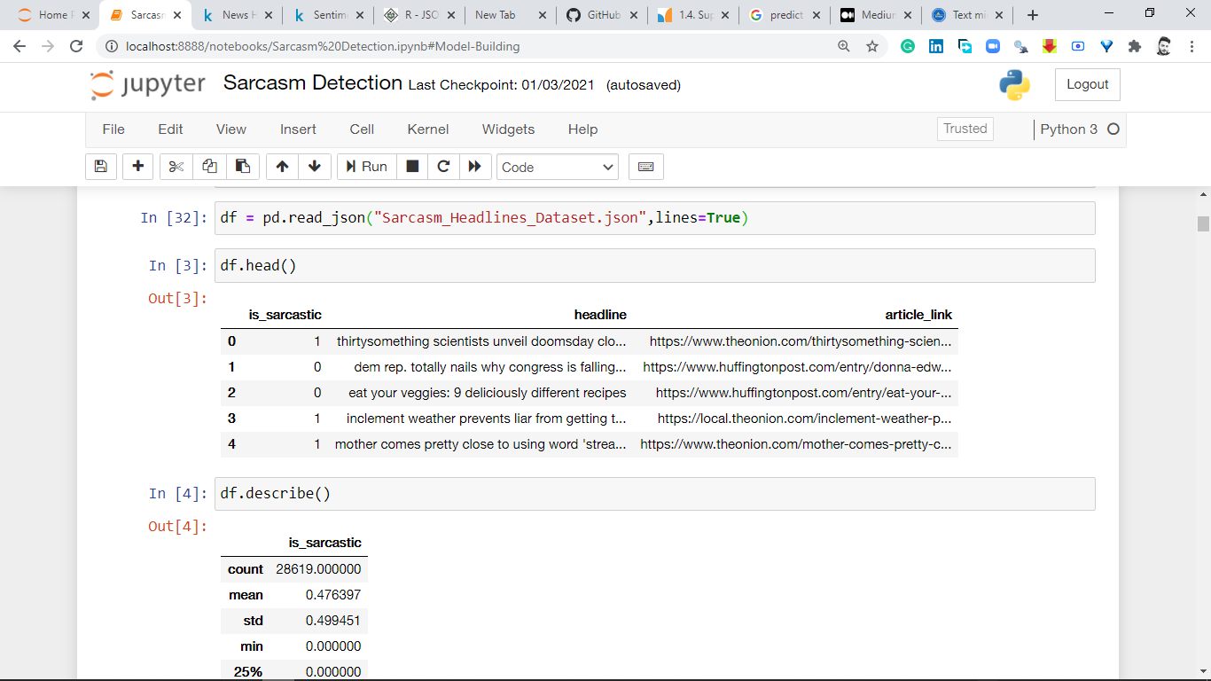

Attributes:-

* is_sarcastic – This column represent the news headline is sarcastic or not
* headline – this column represent the headline
* article_link- this contains the news source link

**1.3 Project Explanation**

This report is an analysis of Text data from Twitter. The data contains tweets from many different languages. We have to classify whether a tweet is **sarcastic or non-sarcastic based on words used** in it. The aim of this project is to build a **Text classification model** to classify statements to sarcastic or non-sarcastic **to understand the true context** in which it appears.

Chapter 2

Methodology



**2.1 Exploratory Data Analysis**

The Given dataset contains 28619 Observations and 3 is_sarcastic, headline and article_link. The Independent variables needed for modelling should be structured, but our only predictor variable is unstructured. So, our first goal is to convert the unstructured headline to structured variables (Terms). We use tm package for this text mining operations involved.

<class 'pandas.core.frame.DataFrame'>

RangeIndex: 28619 entries, 0 to 28618

Data columns (total 3 columns):

# Column Non-Null Count Dtype

--- ------ -------------- -----

0 is_sarcastic 28619 non-null int64

1 headline 28619 non-null object

2 article_link 28619 non-null object

dtypes: int64(1), object(2)

memory usage: 670.9+ KB

**2.1.0. Understanding Data**

Exploratory Data Analysis (EDA) is an approach to analysing data sets and Summarize their main characteristics.Given json data file consists 28619 observation and 3 variables. Data type of all variables is either int64 or object. As per the data analysis we have to find which variables are the categorical variables, continuous variables and target variable. Data types need to be change accordingly. We have distributed the variables on the basis of continuous and categorical variables. Target variable is binary. We have total 28619 observation, but as per above summary tables total observation is equal to 28619. Its means there is no missing values present in our dataset. Missing value analysis is required to further understand the data.

Data set description given below.

<bound method NDFrame.describe of is_sarcastic headline \

0 1 thirtysomething scientists unveil doomsday clo...

1 0 dem rep. totally nails why congress is falling...

2 0 eat your veggies: 9 deliciously different recipes

3 1 inclement weather prevents liar from getting t...

4 1 mother comes pretty close to using word 'strea...

... ... ...

28614 1 jews to celebrate rosh hashasha or something

28615 1 internal affairs investigator disappointed con...

28616 0 the most beautiful acceptance speech this week...

28617 1 mars probe destroyed by orbiting spielberg-gat...

28618 1 dad clarifies this not a food stop

article_link

0 https://www.theonion.com/thirtysomething-scien...

1 https://www.huffingtonpost.com/entry/donna-edw...

2 https://www.huffingtonpost.com/entry/eat-your-...

3 https://local.theonion.com/inclement-weather-p...

4 https://www.theonion.com/mother-comes-pretty-c...

... ...

28614 https://www.theonion.com/jews-to-celebrate-ros...

28615 https://local.theonion.com/internal-affairs-in...

28616 https://www.huffingtonpost.com/entry/andrew-ah...

28617 https://www.theonion.com/mars-probe-destroyed-...

28618 https://www.theonion.com/dad-clarifies-this-no...

[28619 rows x 3 columns]>

**2.1.1. Graphical EDA**

Create Pie chart for see the % distribution of the sarcastic vs Non-sarcastic news headlines.

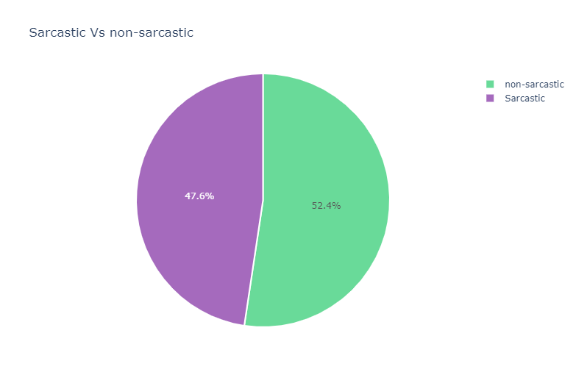

Check the most frequent words in un-clean data

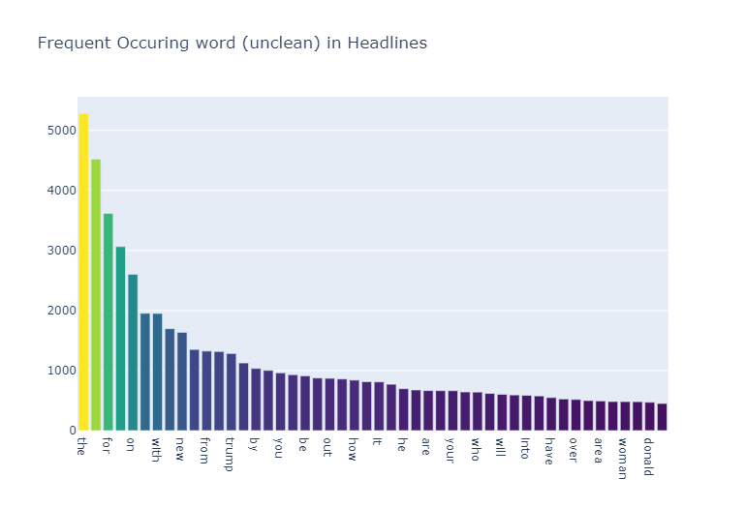

**2.2. Data Pre-processing and text cleaning**

Data pre-processing is the main step of any data science or machine learning project. And this is the steps where most of time a data scientist or machine learning engineer spend. We perform many sub-steps in data pre-processing. In NLP project we perform mainly below performed steps-

**2.2.0. Remove unnecessary characters**

The is a primary step in the process of text cleaning. If we scrap some text from HTML/XML sources, we’ll need to get rid of all the tags, HTML entities, punctuation, non-alphabets, and any other kind of characters which might not be a part of the language. The general methods of such cleaning involve regular expressions, which can be used to filter out most of the unwanted texts.

There are some systems where important English characters like the full-stops, question-marks, exclamation symbols, etc. are retained. Consider an example where you want to perform some sentiment analysis on human generated tweets, and you want to classify the tweets is very angry, angry, neutral, happy, and very happy. Simple sentiment analysis might find it hard to differentiate between a happy, and a very happy sentiment, because there can be some moments only words are not able to explain.

Consider the two sentences with the same semantic meaning:

“This food is good.” and “This. Food. Is. Good!!!!!!!!”.

See what I’m trying to say? Same words, but totally different sentiments, and the only information which can help us to see the different is the overused punctuation, which shows some sort of an “extra” feeling.

Emoticons, which are made up of non-alphabets also play a role in sentiment analysis. “:), :(, -_-, :D, xD”, all these, when processed correctly, can help with a better sentiment analysis. Even if you want to develop a system that may classify whether some phrase is sarcasm, or not sarcasm, such little details can be helpful.

**2.2.1. Tokenization**

Tokenization is the process of breaking up the given text into units called tokens. The tokens may be words or number or punctuation mark. Tokenization does this task by locating word boundaries. Ending point of a word and beginning of the next word is called word boundaries. Tokenization is also known as word segmentation. Before tokenization we will remove the unnecessary characters from data

**2.2.2. Removing Stopwords**

This cleaning step also depends on what you’ll eventually be doing with your data after pre-processing. Stopwords are the words which are used very frequently, and they’re so frequent, that they somewhat lose their semantic meaning. Words like “of, are, the, it, is” are some examples of stopwords. In applications like document search engines and document classification, where keywords are more important than general terms, removing stopwords can be a good idea, but if there’s some application about, for instance, songs lyrics search, or search specific quotes, stopwords can be important. Consider some examples like “To be, or not not be”, “Look what you made me do” etc. Stopwords in such phrases actually play an important role, and hence, should not be dropped. We would not want these words taking up space in our database, or taking up valuable processing time. For this, we can remove them easily, by storing a list of words that you consider to be stop words.

We will remove the stopwords provided by NLTK package from our headlines. Let’s find some words and clean them because stopwords have no meaning for a sentence. We will use python library (nltk) to detect them.

**2.2.3. Stemming/ Lemmatisation**

“The goal of both stemming and lemmatization is to reduce inflectional forms and sometimes derivationally related forms of a word to a common base form.” With that being said, stemming/lemmatizing helps us reduce the number of overall terms to certain “root” terms.

Organizer, organizes, organization, organized all these get reduced to a root term, maybe “organize”.

Stemming is a crude way of reducing terms to their root, by just defining rules of chopping off some characters at the end of the word, and hopefully, gets good results most of the time.

**2.3. Data Visualization**

After complete data pre-processing. I have visualized data and plot some graphs to solve the problem graphically.

2.3.0. Bi-grams

Bi-gram is a two-word sequence of words. like “please turn”, “turn your”, or ”your homework”,

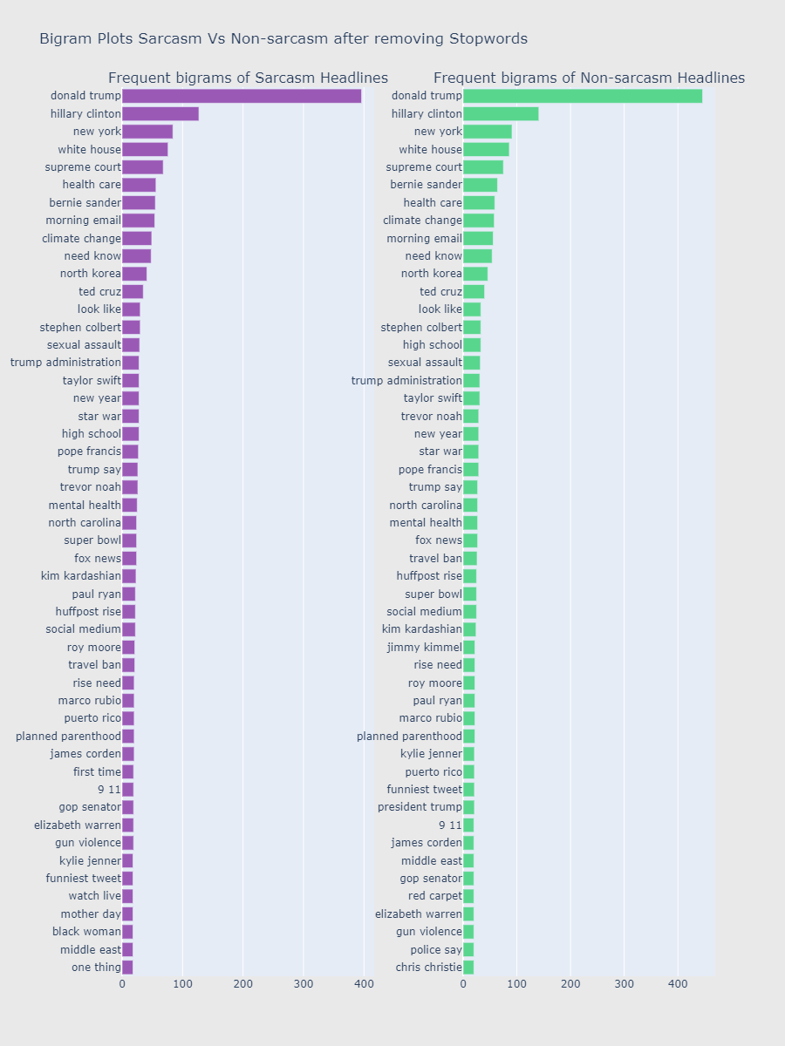

2.3.1. Tri-grams

A trigram is a three-word sequence of words like “please turn your”, or “turn your homework”.

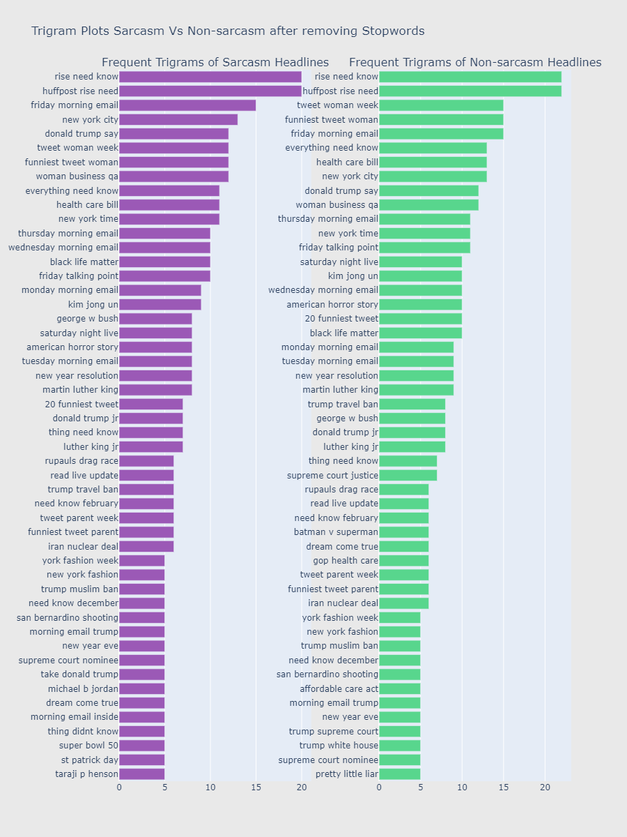

2.3.2. Word cloud

Word cloud for 200 frequant words in complete headlines data.

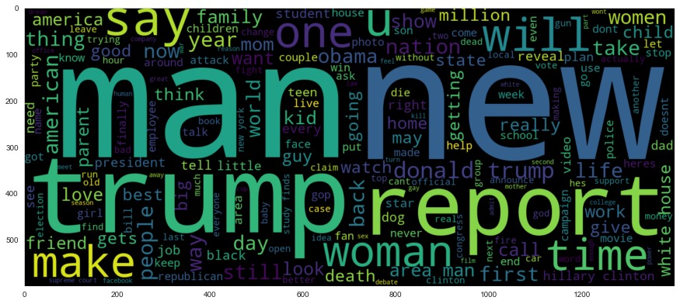

Word cloud for 200 frequant words in non-sarcastic headlines.

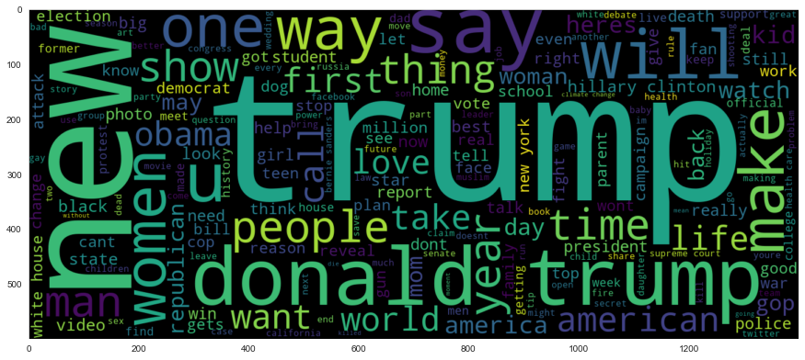

Word cloud for 200 frequant words in non-sarcastic headlines.

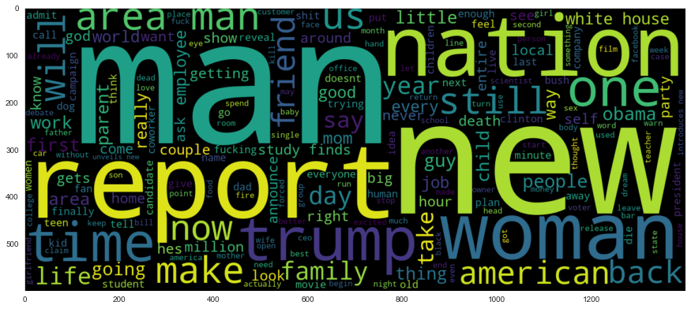

2.3.3. Distribution of Sarcasm Vs Non-sarcasm Headlines

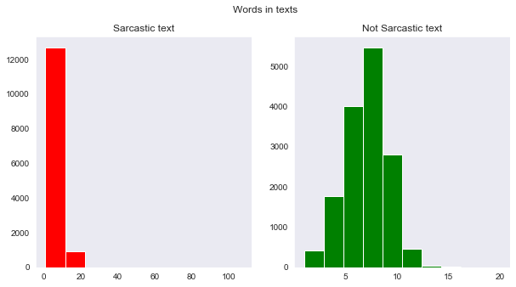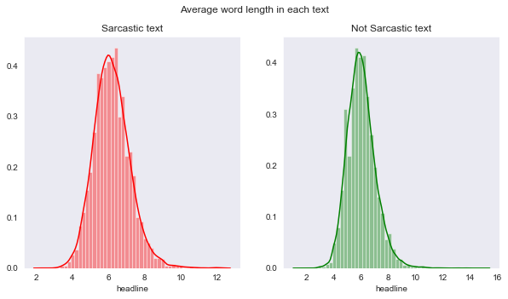

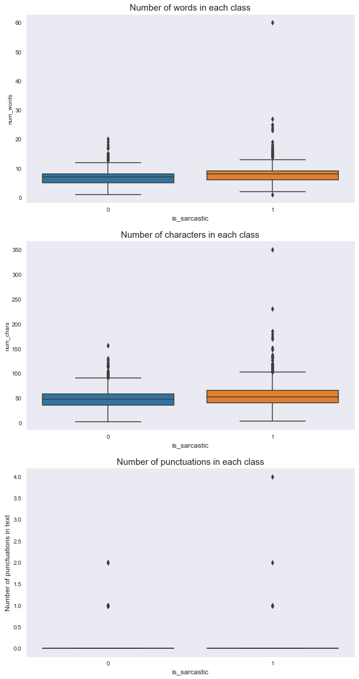

Most 30 frequant words visualization in sarcastic and mon-sarcastic headline after pre-processing.

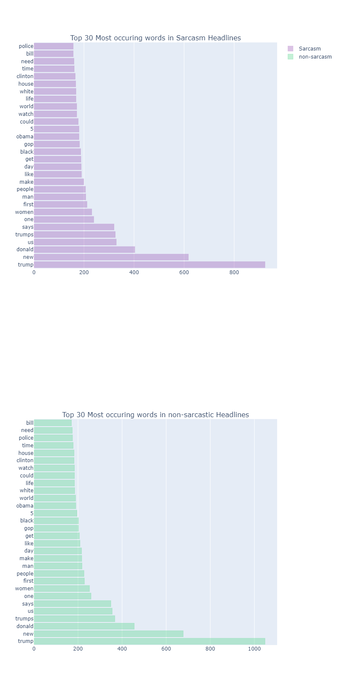

**2.2. Model Development**

Our problem statement wants us to predict the sarcasm in news headline. This is a classification problem. So, we are going to build classification models on training data and predict it on test data. In this project I have built models using 5 classification Algorithms:

**2.2.1. Logistic Regression**

Logistic regression is a statistical model that in its basic form uses a logistic function to model a binary dependent variable, although many more complex extensions exist. In regression analysis, logistic regression (or logit regression) is estimating the parameters of a logistic model (a form of binary regression).

**2.2.2. SVM**

SVM is a supervised machine learning algorithm which can be used for classification or regression problems. It uses a technique called the kernel trick to transform your data and then based on these transformations it finds an optimal boundary between the possible outputs.

**2.2.3. Multinomial NB**

The term Multinomial Naive Bayes simply lets us know that each p(fi|c) is a multinomial distribution, rather than some other distribution. This works well for data which can easily be turned into counts, such as word counts in text.

**2.2.4. Deep Learning Model**

I create a deep learning based model using LSTM layers. We can call it RNN algorithm. Recurrent neural networks (RNN) are the state of the art algorithm for sequential data and are used by Apple's Siri and and Google's voice search. It is the first algorithm that remembers its input, due to an internal memory, which makes it perfectly suited for machine learning problems that involve sequential data

**2.5. Model Evolution**

We will evaluate performance on validation dataset which was generated using Sampling. We will deal with specific metrics like – Classification report and confusion matrix for our Models.

This are the performs reports of all models attached below:-

**Logistic Regression**

**Classification report for LR**

accuracy 0.7802236198462613

precision recall f1-score support

sarcasm 0.79 0.80 0.79 3030

non-sarcasm 0.77 0.76 0.77 2694

accuracy 0.78 5724

macro avg 0.78 0.78 0.78 5724

weighted avg 0.78 0.78 0.78 5724

**Confusion matrix for LR**

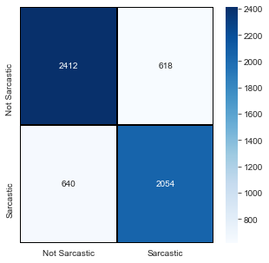

**SVM Model**

**Classification report for SVM**

accuracy 0.8139412997903563

precision recall f1-score support

sarcasm 0.81 0.85 0.83 3030

non-sarcasm 0.82 0.78 0.80 2694

accuracy 0.81 5724

macro avg 0.81 0.81 0.81 5724

weighted avg 0.81 0.81 0.81 5724

**Confusion matrix for SVM**

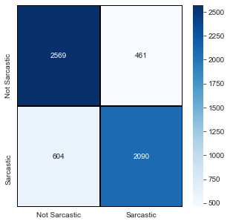

**MNB Model**

Classification report for MNB

accuracy 0.8085255066387141

precision recall f1-score support

sarcasm 0.79 0.86 0.83 3030

non-sarcasm 0.83 0.75 0.79 2694

accuracy 0.81 5724

macro avg 0.81 0.81 0.81 5724

weighted avg 0.81 0.81 0.81 5724

**Confusion matrix for MNB**

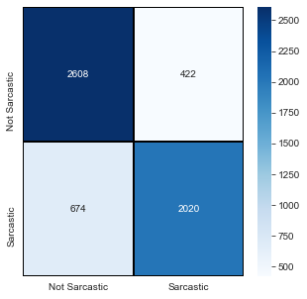

**Deep Learning Model**

**Classification report for DL Model**

accuracy 0.8039832285115304

precision recall f1-score support

sarcasm 0.81 0.82 0.81 2991

non-sarcasm 0.80 0.78 0.79 2733

accuracy 0.80 5724

macro avg 0.80 0.80 0.80 5724

weighted avg 0.80 0.80 0.80 5724

**Confusion matrix for DL Model**

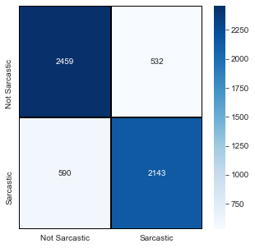

Chapter 3

Conclusion



**Asked questions in problem statement:**

**Question 1**. Find the 6 topics related to news article headlines.

**Answer 1**. After Analysis of news headlines I got below 6 topic that are more related to news headlines-

1. Politics
2. Entertainments
3. Sport
4. Study
5. Medical
6. Travel

**Question 2.** Do EDA to find the top 50 sarcastic words. Make a word cloud for top 200 frequent words.

**Answer 2.** These are the top 50 sarcastic words-

| **index** | **Words** | **Freq** |
| --- | --- | --- |
| **0** | trump | 923 |
| **1** | new | 617 |
| **2** | donald | 403 |
| **3** | us | 329 |
| **4** | trumps | 325 |
| **5** | says | 320 |
| **6** | one | 239 |
| **7** | women | 231 |
| **8** | first | 212 |
| **9** | man | 207 |
| **10** | people | 206 |
| **11** | make | 199 |
| **12** | like | 190 |
| **13** | day | 189 |
| **14** | get | 188 |
| **15** | black | 187 |
| **16** | gop | 182 |
| **17** | obama | 180 |
| **18** | 5 | 180 |
| **19** | could | 177 |
| **20** | watch | 171 |
| **21** | world | 171 |
| **22** | life | 168 |
| **23** | white | 168 |
| **24** | house | 167 |
| **25** | clinton | 165 |
| **26** | time | 161 |
| **27** | need | 160 |
| **28** | bill | 157 |
| **29** | police | 157 |
| **30** | heres | 155 |
| **31** | best | 152 |
| **32** | years | 151 |
| **33** | health | 150 |
| **34** | video | 149 |
| **35** | hillary | 147 |
| **36** | things | 146 |
| **37** | know | 145 |
| **38** | love | 144 |
| **39** | president | 143 |
| **40** | say | 141 |
| **41** | 10 | 135 |
| **42** | woman | 135 |
| **43** | way | 134 |
| **44** | show | 131 |
| **45** | kids | 129 |
| **46** | may | 123 |
| **47** | dont | 120 |
| **48** | change | 119 |
| **49** | want | 118 |

And the word cloud for 200 frequant words in complete headlines data.



Word cloud for 200 frequant words in non-sarcastic headlines.



Word cloud for 200 frequant words in non-sarcastic headlines.



**Question 3.** Can you identify sarcastic sentences? Can you distinguish between fake news and

legitimate news?

**Answer 3.** I have identify first 10 headlines of test data using created model. And got below results

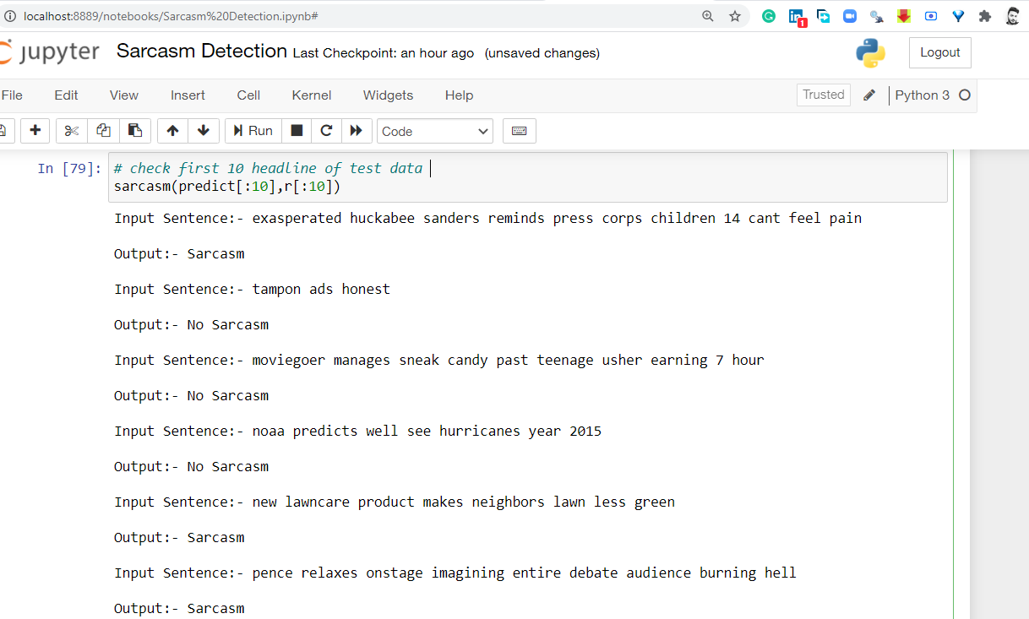

On the base of model classification we can identify if model predict the 0 then this news headline will be non-sarcastic and if model predict the 1 then this news headline will be sarcastic. In general if a news is not real then it will we sarcastic news. If the news has really correct then it will have proper details at its source point.

Chapter 4

Codes





4.1. Python code

# In[1]:

#import all necessary libs

import warnings

warnings.filterwarnings('ignore')

import pandas as pd

import numpy as np

import matplotlib.pyplot as plt

import seaborn as sns

import chart_studio.plotly as py

import plotly.graph_objs as go

from plotly.offline import download_plotlyjs, init_notebook_mode, plot, iplot

init_notebook_mode(connected=True)

from sklearn.linear_model import LogisticRegression

from sklearn.naive_bayes import MultinomialNB

from sklearn.svm import SVC

from collections import Counter

import string

import nltk

from sklearn.preprocessing import LabelBinarizer

from nltk.corpus import stopwords

from nltk.stem.porter import PorterStemmer

from wordcloud import WordCloud,STOPWORDS

from nltk.stem import WordNetLemmatizer

from nltk.tokenize import word_tokenize,sent_tokenize

from bs4 import BeautifulSoup

import re,string,unicodedata

from keras.preprocessing import text, sequence

from sklearn.metrics import classification_report,confusion_matrix,accuracy_score

from sklearn.model_selection import train_test_split

from string import punctuation

import keras

from keras.models import Sequential

from keras.layers import Dense,Embedding,LSTM,Dropout,Bidirectional,GRU

import tensorflow as tf

# In[2]:

# read the data file

data = pd.read_json("Sarcasm_Headlines_Dataset.json",lines=True)

df=data.copy()

# In[3]:

# CHeck the top 5 rows of the data set

df.head()

# In[4]:

# describtion of data

df.describe()

# In[5]:

# check the information of the data

df.info()

# In[6]:

df.describe

# ### Dataset Exploratory Data Analysis

# In the dataset, if headline is sarcastic, "is_sarcastic" column value 1. If not sarcastic, value=0. Also article value is provided. But our main focus is to build a model that can detect sarcastic news based on "headline" and "is_sarcastic" column.

# In[7]:

#lets find if there is any NaN valus, because NaN values give wrong visualization

df.isna().sum()

# In[8]:

#Lets drop the "article link" column from dataframe as it is not needed

#del df['article_link']

# In[9]:

#Lets create a barplot/countplot to compare between sarcastic or non-sarcastic news

sns. set_style("dark")

sns.countplot(df.is_sarcastic);

# so there are almost same number of sarcastic and non-sarcastic news.

# In[10]:

# Check the different sourse of news

df.article_link.apply(lambda x: x.split('.')[1]).value_counts()

# In[11]:

# create website column for sourse link of the news

df['website'] = df.article_link.apply(lambda x: x.split('.')[1])

df.info()

# In[12]:

#view different news sourses

sns.countplot(x= df.website ,data=df, order = df['website'].value_counts().index);

# In[13]:

sar_acc_tar = df['is_sarcastic'].value_counts()

labels = ['non-sarcastic', 'Sarcastic']

sizes = (np.array((sar_acc_tar / sar_acc_tar.sum())*100))

colors = ['#58D68D', '#9B59B6']

trace = go.Pie(labels=labels, values=sizes, opacity = 0.9, hoverinfo='label+percent',

marker=dict(colors=colors, line=dict(color='#FFFFFF', width=2)))

layout = go.Layout(

title='Sarcastic Vs non-sarcastic'

)

data = [trace]

fig = go.Figure(data=data, layout=layout)

iplot(fig, filename="Sa_Ac")

# #### Frequent Occuring word (unclean) in Headlines

# In[14]:

all_words = df['headline'].str.split(expand=True).unstack().value_counts()

data = [go.Bar(

x = all_words.index.values[2:50],

y = all_words.values[2:50],

marker= dict(colorscale='Viridis',

color = all_words.values[2:100]

),

text='Word counts'

)]

layout = go.Layout(

title='Frequent Occuring word (unclean) in Headlines'

)

fig = go.Figure(data=data, layout=layout)

iplot(fig, filename='basic-bar')

# From the above plot its clearly evident that the headlines need to be cleaned as the top 50 most occuring words are joing words and indirect words which does not provide any meaning.

# ## Tokenization

# Tokenization is the process of breaking up the given text into units called tokens. The tokens may be words or number or punctuation mark. Tokenization does this task by locating word boundaries. Ending point of a word and beginning of the next word is called word boundaries. Tokenization is also known as word segmentation.

#

# Before tokenization we will remove the unnecessary characters from data

# In[16]:

REPLACE_BY_SPACE_RE = re.compile('[/(){}\[\]\|@,;:]')

BAD_SYMBOLS_RE = re.compile('[^0-9a-z #+_]')

def clean_text(text):

"""

text: a string

return: modified initial string

"""

text = BeautifulSoup(text, "lxml").text # HTML decoding

text = text.lower() # lowercase text

text = REPLACE_BY_SPACE_RE.sub(' ', text) # replace REPLACE_BY_SPACE_RE symbols by space in text

text = BAD_SYMBOLS_RE.sub('', text) # delete symbols which are in BAD_SYMBOLS_RE from text

return text

df['headline'] = df['headline'].apply(clean_text)

# In[17]:

#non-sarcatic headlines tokenization

n_sar_list=[]

for i in df[df['is_sarcastic']==0]['headline'].values:

n_sar_list.append(i.split())

# In[18]:

n_sar=[]

for i in range(len(n_sar_list)):

for j in n_sar_list[i]:

n_sar.append(j)

# In[19]:

#sarcatic headlines tokenization

sar_list=[]

for i in df[df['is_sarcastic']==1]['headline'].values:

l=i.split()

sar_list.append(l)

# In[20]:

sar = []

for i in range(len(sar_list)):

for j in n_sar_list[i]:

sar.append(j)

# ## Removing Stopwords

#

# A stop word is a commonly used word (such as “the”, “a”, “an”, “in”) that a search engine has been programmed to ignore, both when indexing entries for searching and when retrieving them as the result of a search query.

#

# We would not want these words taking up space in our database, or taking up valuable processing time. For this, we can remove them easily, by storing a list of words that you consider to be stop words.

#

# We will remove the stopwords provided by NLTK package from our headlines.

# Lets find some somewords and clean them because stopwords have no meaning for a sentence. we will use python library(nltk) to detect them.

# In[21]:

#set and define stop word

#nltk.download('stopwords')

stopwords = set(nltk.corpus.stopwords.words('english'))

punctuation = list(string.punctuation)

stopwords.update(punctuation)

# In[22]:

sar_list_restp = [word for word in sar if word.lower() not in stopwords]

n_sar_list_restp = [word for word in n_sar if word.lower() not in stopwords]

print("Length of original Sarcasm list: {0} words\n"

"Length of Sarcasm list after stopwords removal: {1} words"

.format(len(sar), len(sar_list_restp)))

print("=="*46)

print("Length of original non_sarcastic list: {0} words\n"

"Length of non_sarcastic list after stopwords removal: {1} words"

.format(len(n_sar), len(n_sar_list_restp)))

# In[23]:

def remove_stopwd(text):

text = ' '.join(word for word in text.split() if word not in STOPWORDS) # delete stopwors from text

return text

df['headline']=df['headline'].apply(remove_stopwd)

# In[24]:

df.head()

# #### Top 30 Occuring words after removing Stopwords from Headlines - Sarcasm Vs Non-sarcasm

# In[25]:

#Data cleaning for getting top 30

sar_cnt = Counter(sar_list_restp)

acc_cnt = Counter(n_sar_list_restp)

#Dictonary to Dataframe

sar_cnt_df = pd.DataFrame(list(sar_cnt.items()), columns = ['Words', 'Freq'])

sar_cnt_df = sar_cnt_df.sort_values(by=['Freq'], ascending=False)

acc_cnt_df = pd.DataFrame(list(acc_cnt.items()), columns = ['Words', 'Freq'])

acc_cnt_df = acc_cnt_df.sort_values(by=['Freq'], ascending=False)

#Top 30

sar_cnt_df_30 = sar_cnt_df.head(30)

acc_cnt_df_30 = acc_cnt_df.head(30)

# In[26]:

#Plotting the top 30 Sarcasm Vs Acclaim

from plotly import tools

sar_tr = go.Bar(

x=sar_cnt_df_30['Freq'],

y=sar_cnt_df_30['Words'],

name='Sarcasm',

marker=dict(

color='rgba(155, 89, 182, 0.6)',

line=dict(

color='rgba(155, 89, 182, 1.0)',

width=.3,

)

),

orientation='h',

opacity=0.6

)

acc_tr = go.Bar(

x=acc_cnt_df_30['Freq'],

y=acc_cnt_df_30['Words'],

name='non-sarcasm',

marker=dict(

color='rgba(88, 214, 141, 0.6)',

line=dict(

color='rgba(88, 214, 141, 1.0)',

width=.5,

)

),

orientation='h',

opacity=0.6

)

fig = tools.make_subplots(rows=2, cols=1, subplot_titles=('Top 30 Most occuring words in Sarcasm Headlines',

'Top 30 Most occuring words in non-sarcastic Headlines'))

fig.append_trace(sar_tr, 1, 1)

fig.append_trace(acc_tr, 2, 1)

fig['layout'].update(height=1600, width=800)

iplot(fig, filename='sar_vs_n_sar')

# ### Stemming

# In linguistic morphology and information retrieval, stemming is the process of reducing inflected (or sometimes derived) words to their word stem, base or root form - generally a written word form. The stem need not be identical to the morphological root of the word; it is usually sufficient that related words map to the same stem, even if this stem is not in itself a valid root.

#

# Source:

# https://en.wikipedia.org/wiki/Stemming

#

# NLTK provides three different forms of steamming namely Porter stemming algorithm, the lancaster stemmer and the Snowball stemmer. Here, for our analysis we will be using Snowball stemmer.

# In[27]:

# Example of snowballstemmer algorithm

stemmer = nltk.stem.SnowballStemmer("english", ignore_stopwords=True)

print("The stemmed form of learning is: {}".format(stemmer.stem("learning")))

print("The stemmed form of learns is: {}".format(stemmer.stem("learns")))

print("The stemmed form of learn is: {}".format(stemmer.stem("learn")))

print("=="*46)

print("The stemmed form of leaves is: {}".format(stemmer.stem("leaves")))

print("=="*46)

# Here is the caveat in using stemming. In the above example for the word 'leaves', it just stemms the word. As the name 'stemming' suggest, it at times simply stems the word which will become meaningless. So, to overcome this issue we have lemmatization.

# ### Lemmatisation

#

#

# Lemmatisation (or lemmatization) in linguistics is the process of grouping together the inflected forms of a word so they can be analysed as a single item, identified by the word's lemma, or dictionary form. Unlike a stemmer, lemmatizing the dataset aims to reduce words based on an actual dictionary or vocabulary (the Lemma) and therefore will not chop off words into stemmed forms that do not carry any lexical meaning.

#

# Source:

# https://en.wikipedia.org/wiki/Lemmatisation

# In[28]:

#download wordnet

# nltk.download('wordnet')

# In[29]:

lemm = WordNetLemmatizer()

print("The lemmatized form of leaves is: {}".format(lemm.lemmatize("leaves")))

# In[30]:

sar_wost_lem=[]

sar_list_lemm = [lemm.lemmatize(word) for word in sar_list_restp]

sar_wost_lem.append(sar_list_lemm)

# In[31]:

n_sar_wost_lem = []

n_sar_list_lemm = [lemm.lemmatize(word) for word in n_sar_list_restp]

n_sar_wost_lem.append(n_sar_list_lemm)

# In[32]:

# top 50 frequant sarcastic word

sar_cnt_df.head(50).reset_index(drop=True)

# ### Bi-grams

#

# A bigram or digram is a sequence of two adjacent elements from a string of tokens, which are typically letters, syllables, or words. A bigram is an n-gram for n=2. The frequency distribution of every bigram in a string is commonly used for simple statistical analysis of text in many applications, including in computational linguistics, cryptography, speech recognition, and so on.

#

# Source:

# https://en.wikipedia.org/wiki/Bigram

# In[33]:

sar_wost_lem_df = pd.DataFrame({'sarcasm':sar_wost_lem})

n_sar_wost_lem_df = pd.DataFrame({'Non-sarcasm':n_sar_wost_lem})

## custom function for ngram generation ##

def generate_ngrams(text, n_gram=1):

ngrams = zip(*[text[i:] for i in range(n_gram)])

return [" ".join(ngram) for ngram in ngrams]

## custom function for horizontal bar chart ##

def horizontal_bar_chart(df, color):

trace = go.Bar(

y=df["word"].values[::-1],

x=df["wordcount"].values[::-1],

showlegend=False,

orientation = 'h',

marker=dict(

color=color,

),

)

return trace

#Plotting the Bigram plot

from collections import defaultdict

freq_dict = defaultdict(int)

for sent in sar_wost_lem_df["sarcasm"]:

for word in generate_ngrams(sent,2):

freq_dict[word] += 1

fd_sorted = pd.DataFrame(sorted(freq_dict.items(), key=lambda x: x[1])[::-1])

fd_sorted.columns = ["word", "wordcount"]

sar_2 = horizontal_bar_chart(fd_sorted.head(50), '#9B59B6')

freq_dict = defaultdict(int)

for sent in n_sar_wost_lem_df["Non-sarcasm"]:

for word in generate_ngrams(sent,2):

freq_dict[word] += 1

fd_sorted = pd.DataFrame(sorted(freq_dict.items(), key=lambda x: x[1])[::-1])

fd_sorted.columns = ["word", "wordcount"]

acc_2 = horizontal_bar_chart(fd_sorted.head(50), '#58D68D')

# Creating two subplots

fig = tools.make_subplots(rows=1, cols=2, vertical_spacing=0.04,horizontal_spacing=0.15,

subplot_titles=["Frequent bigrams of Sarcasm Headlines",

"Frequent bigrams of Non-sarcasm Headlines"])

fig.append_trace(sar_2, 1, 1)

fig.append_trace(acc_2, 1, 2)

fig['layout'].update(height=1200, width=900, paper_bgcolor='rgb(233,233,233)', title="Bigram Plots Sarcasm Vs Non-sarcasm after removing Stopwords")

iplot(fig, filename='word-plots')

# ### Trigram

# In[34]:

#Plotting the Trigram plot

from collections import defaultdict

freq_dict = defaultdict(int)

for sent in sar_wost_lem_df["sarcasm"]:

for word in generate_ngrams(sent,3):

freq_dict[word] += 1

fd_sorted = pd.DataFrame(sorted(freq_dict.items(), key=lambda x: x[1])[::-1])

fd_sorted.columns = ["word", "wordcount"]

sar_2 = horizontal_bar_chart(fd_sorted.head(50), '#9B59B6')

freq_dict = defaultdict(int)

for sent in n_sar_wost_lem_df["Non-sarcasm"]:

for word in generate_ngrams(sent,3):

freq_dict[word] += 1

fd_sorted = pd.DataFrame(sorted(freq_dict.items(), key=lambda x: x[1])[::-1])

fd_sorted.columns = ["word", "wordcount"]

acc_2 = horizontal_bar_chart(fd_sorted.head(50), '#58D68D')

# Creating two subplots

fig = tools.make_subplots(rows=1, cols=2, vertical_spacing=0.04,horizontal_spacing=0.15,

subplot_titles=["Frequent Trigrams of Sarcasm Headlines",

"Frequent Trigrams of Non-sarcasm Headlines"])

fig.append_trace(sar_2, 1, 1)

fig.append_trace(acc_2, 1, 2)

fig['layout'].update(height=1200, width=900, paper_bgcolor='rgb(233,233,233)', title="Trigram Plots Sarcasm Vs Non-sarcasm after removing Stopwords")

iplot(fig, filename='word-plots')

# ### Wordcloud

#

# Create wordcloud for top 200 frequant word in all headlines

# In[35]:

plt.figure(figsize = (15,15)) # non-sarcastic words wordcloud

wordcld = WordCloud(max_words = 200 , width = 1400 , height = 600).generate(" ".join(df.headline))

plt.imshow(wordcld , interpolation = 'bilinear');

# Lets create a wordcloud from non-sarcastic news which will give us a view of sights which words are used here most

# In[36]:

plt.figure(figsize = (15,15)) # non-sarcastic words wordcloud

wordcld = WordCloud(max_words = 200 , width = 1400 , height = 600).generate(" ".join(df[df.is_sarcastic == 0].headline))

plt.imshow(wordcld , interpolation = 'bilinear');

# Lets create a wordcloud from sarcastic news which will give us a view of sights which words are used here most

# In[37]:

plt.figure(figsize = (15,15)) # non-sarcastic words wordcloud

wordcld = WordCloud(max_words = 200 , width = 1400 , height = 600).generate(" ".join(df[df.is_sarcastic == 1].headline))

plt.imshow(wordcld , interpolation = 'bilinear');

# #### Distribution of Sarcasm Vs Non-sarcasm Headlines

# In[38]:

## Number of words in the text ##

df["num_words"] = df["headline"].apply(lambda x: len(str(x).split()))

## Number of unique words in the text ##

df["num_unique_words"] = df["headline"].apply(lambda x: len(set(str(x).split())))

## Number of characters in the text ##

df["num_chars"] = df["headline"].apply(lambda x: len(str(x)))

## Number of stopwords in the text ##

df["num_stopwords"] = df["headline"].apply(lambda x: len([w for w in str(x).lower().split() if w in STOPWORDS]))

## Number of punctuations in the text ##

df["num_punctuations"] =df['headline'].apply(lambda x: len([c for c in str(x) if c in string.punctuation]) )

## Number of title case words in the text ##

df["num_words_upper"] = df["headline"].apply(lambda x: len([w for w in str(x).split() if w.isupper()]))

## Number of title case words in the text ##

df["num_words_title"] = df["headline"].apply(lambda x: len([w for w in str(x).split() if w.istitle()]))

## Average length of the words in the text ##

df["mean_word_len"] = df["headline"].apply(lambda x: np.mean([len(w) for w in str(x).split()]))

# In[39]:

df.head()

# In[40]:

## Truncate some extreme values for better visuals ##

import matplotlib.pyplot as plt

import seaborn as sns

color = sns.color_palette()

df['num_words'].loc[df['num_words']>60] = 60 #truncation for better visuals

df['num_punctuations'].loc[df['num_punctuations']>10] = 10 #truncation for better visuals

df['num_chars'].loc[df['num_chars']>350] = 350 #truncation for better visuals

df['num_words'].loc[df['num_words']>60] = 60 #truncation for better visuals

df['num_punctuations'].loc[df['num_punctuations']>10] = 10 #truncation for better visuals

df['num_chars'].loc[df['num_chars']>350] = 350 #truncation for better visuals

f, axes = plt.subplots(3, 1, figsize=(10,20))

sns.boxplot(x='is_sarcastic', y='num_words', data=df, ax=axes[0])

axes[0].set_xlabel('is_sarcastic', fontsize=12)

axes[0].set_title("Number of words in each class", fontsize=15)

sns.boxplot(x='is_sarcastic', y='num_chars', data=df, ax=axes[1])

axes[1].set_xlabel('is_sarcastic', fontsize=12)

axes[1].set_title("Number of characters in each class", fontsize=15)

sns.boxplot(x='is_sarcastic', y='num_punctuations', data=df, ax=axes[2])

axes[2].set_xlabel('is_sarcastic', fontsize=12)

plt.ylabel('Number of punctuations in text', fontsize=12)

axes[2].set_title("Number of punctuations in each class", fontsize=15)

plt.show()

# Lets visualize number of words and each word length in dataset

# In[41]:

#number of words

fig,(ax1,ax2)=plt.subplots(1,2,figsize=(10,5))

text_len=df[df['is_sarcastic']==1]['headline'].str.split().map(lambda x: len(x))

ax1.hist(text_len,color='red')

ax1.set_title('Sarcastic text')

text_len=df[df['is_sarcastic']==0]['headline'].str.split().map(lambda x: len(x))

ax2.hist(text_len,color='green')

ax2.set_title('Not Sarcastic text')

fig.suptitle('Words in texts')

plt.show()

#average word length

fig,(ax1,ax2)=plt.subplots(1,2,figsize=(10,5))

word=df[df['is_sarcastic']==1]['headline'].str.split().apply(lambda x : [len(i) for i in x])

sns.distplot(word.map(lambda x: np.mean(x)),ax=ax1,color='red')

ax1.set_title('Sarcastic text')

word=df[df['is_sarcastic']==0]['headline'].str.split().apply(lambda x : [len(i) for i in x])

sns.distplot(word.map(lambda x: np.mean(x)),ax=ax2,color='green')

ax2.set_title('Not Sarcastic text')

fig.suptitle('Average word length in each text')

# #### Lets split dataset into train and test

# In[43]:

X = df.headline

Y = df.is_sarcastic

X_train, X_test, Y_train, Y_test = train_test_split(X, Y, test_size=0.20, random_state = 0)

# # Model Building

# ### Logistic Regression

# In[44]:

from sklearn.pipeline import Pipeline

from sklearn.feature_extraction.text import TfidfTransformer

from sklearn.feature_extraction.text import CountVectorizer

logreg = Pipeline([('vect', CountVectorizer()),

('tfidf', TfidfTransformer()),

('clf', LogisticRegression(n_jobs=1, C=1e5)),

])

logreg.fit(X_train, Y_train)

logreg_pred = logreg.predict(X_test)

print('accuracy %s' % accuracy_score(logreg_pred, Y_test))

print(classification_report(Y_test, logreg_pred,target_names=['sarcasm','non-sarcasm']))

# In[45]:

conmat=confusion_matrix(Y_test,logreg_pred)

conmat = pd.DataFrame(conmat , index = ['Not Sarcastic','Sarcastic'] , columns = ['Not Sarcastic','Sarcastic'])

plt.figure(figsize = (5,5))

sns.heatmap(conmat,cmap= "Blues", linecolor = 'black' , linewidth = 1 , annot = True, fmt='' , xticklabels = ['Not Sarcastic','Sarcastic'] , yticklabels = ['Not Sarcastic','Sarcastic']);

# ## SVM

# In[46]:

svm = Pipeline([('vect', CountVectorizer()),

('tfidf', TfidfTransformer()),

('clf', SVC()),

])

svm.fit(X_train, Y_train)

svm_pred = svm.predict(X_test)

print('accuracy %s' % accuracy_score(svm_pred, Y_test))

print(classification_report(Y_test, svm_pred,target_names=['sarcasm','non-sarcasm']))

# In[47]:

conmat=confusion_matrix(Y_test,svm_pred)

conmat = pd.DataFrame(conmat , index = ['Not Sarcastic','Sarcastic'] , columns = ['Not Sarcastic','Sarcastic'])

plt.figure(figsize = (5,5))

sns.heatmap(conmat,cmap= "Blues", linecolor = 'black' , linewidth = 1 , annot = True, fmt='' , xticklabels = ['Not Sarcastic','Sarcastic'] , yticklabels = ['Not Sarcastic','Sarcastic']);

# ### MultinomialNB

# In[48]:

nb = Pipeline([('vect', CountVectorizer()),

('tfidf', TfidfTransformer()),

('clf', MultinomialNB()),

])

nb.fit(X_train, Y_train)

from sklearn.metrics import classification_report

nb_pred = nb.predict(X_test)

print('accuracy %s' % accuracy_score(nb_pred, Y_test))

print(classification_report(Y_test, nb_pred,target_names=['sarcasm','non-sarcasm']))

# In[49]:

conmat=confusion_matrix(Y_test,nb_pred)

conmat = pd.DataFrame(conmat , index = ['Not Sarcastic','Sarcastic'] , columns = ['Not Sarcastic','Sarcastic'])

plt.figure(figsize = (5,5))

sns.heatmap(conmat,cmap= "Blues", linecolor = 'black' , linewidth = 1 , annot = True, fmt='' , xticklabels = ['Not Sarcastic','Sarcastic'] , yticklabels = ['Not Sarcastic','Sarcastic']);

# ### LETS BUILD DEEP LEARNING MODEL AND TRAIN

# ### Prepare training and testing data for deeplearning model

# Now we will use word2vec, tokenization, padding using keras text and word preprocessing libraries.

# In[50]:

#lets convert our text data into more acceptable format

#split words from a sentence and keep is sentence in the list which will help us for tokenization

words = []

for i in df.headline.values:

words.append(i.split())

print("splitted words:",words[:5])

# use genism lib for word2vec wordembedding

import gensim

#Dim for max embedding

EMBEDDING_DIM = 200

#lets create word2vec model

w2v_model = gensim.models.Word2Vec(sentences = words , size=EMBEDDING_DIM , window = 5 , min_count = 1)

# now we will use tokenizer which keep tracks of every word in dataset by assigning an unique token for each word. Also to match length of each sentence, padding can be used

#

# In[51]:

# import keras.preprocessing lib for token

tokenizer = text.Tokenizer(num_words=38071)

tokenizer.fit_on_texts(words)

tokenized_traindata = tokenizer.texts_to_sequences(words)

x = sequence.pad_sequences(tokenized_traindata, maxlen = 20)

# In[52]:

x_train, x_test, y_train, y_test = train_test_split(x, df.is_sarcastic , test_size = 0.20 , random_state = 0)

# In[53]:

print("before tokenization:",len(w2v_model.wv.vocab))

# vocab size increases by 1

vocab_size = len(tokenizer.word_index) + 1

print("after tokenization, vocab_size:", vocab_size)

# here we see after tokenization, size increases by 1 because of extra index for unknown words

# #### Lets create word vectors by creating weight matrix for non-embedding keras layers

# In[54]:

#generate weightmatrix using numpy zeros

weight_matrix=np.zeros((vocab_size, EMBEDDING_DIM))

#lets fill each zeros with value model

for word, k in tokenizer.word_index.items():

weight_matrix[k] = w2v_model[word]

# In[55]:

#define dnn model

model = Sequential()

#adding embeddidng layers using bidirectional LSTM

model.add(Embedding(vocab_size, output_dim=EMBEDDING_DIM, weights=[weight_matrix], input_length=20, trainable=True))

model.add(Bidirectional(LSTM(units=128 , recurrent_dropout = 0.2 , dropout = 0.2,return_sequences = True)))

model.add(Bidirectional(GRU(units=64 , recurrent_dropout = 0.1 , dropout = 0.1)))

model.add(Dense(1, activation='sigmoid'))

model.compile(optimizer=keras.optimizers.Adam(lr = 0.0001), loss='binary_crossentropy', metrics=['acc'])

model.summary()

# In[58]:

#Lets train our model

from keras.callbacks import EarlyStopping

history = model.fit(x_train, y_train, batch_size = 100 , validation_split =0.1 , epochs = 5,callbacks=[EarlyStopping(monitor='val_loss',min_delta=0.0001)])

# In[60]:

# Lets analyze training and validation accuracy/loss

epochs = [i for i in range(4)]

fig , ax = plt.subplots(1,2)

train_acc = history.history['acc']

train_loss = history.history['loss']

val_acc = history.history['val_acc']

val_loss = history.history['val_loss']

fig.set_size_inches(20,10)

ax[0].plot(epochs , train_acc , 'go-' , label = 'Training Accuracy')

ax[0].plot(epochs , val_acc , 'ro-' , label = 'Testing Accuracy')

ax[0].set_title('Training & Testing Accuracy')

ax[0].legend()

ax[0].set_xlabel("Epochs")

ax[0].set_ylabel("Accuracy")

ax[1].plot(epochs , train_loss , 'go-' , label = 'Training Loss')

ax[1].plot(epochs , val_loss , 'ro-' , label = 'Testing Loss')

ax[1].set_title('Training & Testing Loss')

ax[1].legend()

ax[1].set_xlabel("Epochs")

ax[1].set_ylabel("Loss")

plt.show()

# In[69]:

#predict values over x_test data

predict = model.predict_classes(x_test)

# In[68]:

predict[:10]

# In[62]:

#lets use confusion matrix to check on predictions

conmat=confusion_matrix(y_test,predict)

conmat = pd.DataFrame(conmat , index = ['Not Sarcastic','Sarcastic'] , columns = ['Not Sarcastic','Sarcastic'])

plt.figure(figsize = (5,5))

sns.heatmap(conmat,cmap= "Blues", linecolor = 'black' , linewidth = 1 , annot = True, fmt='' , xticklabels = ['Not Sarcastic','Sarcastic'] , yticklabels = ['Not Sarcastic','Sarcastic']);

# In[63]:

#check classification report

print(classification_report(y_test, predict, target_names = ['Not Sarcastic','Sarcastic']))

# In[64]:

# get index of values of getting headline

r=y_test.index

# In[65]:

# Create a funcation to check test data is sarcastic or non-sarcastic

def sarcasm(a,b):

for i,j in zip(a,b):

print(df.headline[j])

result = i

if (result[0]==1):

pos=1

else:

pos=0

sentiment_dict = {0:'No Sarcasm',1:'Sarcasm'}

print(sentiment_dict[pos] +"\n" )

return

# In[67]:

# check first 50 value of test data

sarcasm(predict[:50],r[:50])

# ## Thank you for review

# submitted by: Arun Kumar

# arunk.recs.cse@gmail.com

Chapter 4

Codes





4.2 R Code

# clear the environment

rm(list= ls())

# check and set working directory

getwd()

setwd(getwd())

# loading required libraries

require('tm') # for text mining

require('data.table') # for faster data operations

library("keras")

library('jsonlite')

library('tidyverse')

require('wordcloud')

require('ggplot2')

require("caTools")

require("e1071")

# read in our json file (one object person)

headlines <- file("Sarcasm_Headlines_Dataset.json", open = "r") %>%

stream_in() %>%as_data_frame()

# checking structure and summary

dim(headlines)

str(headlines)

summary(headlines)

head(headlines)

tail(headlines)

# vec2clean.corp function takes two arguments: x = vector to be cleaned, y = document number to show the process by printing

vec2clean.corp <- function(x,y=NULL){

# As there are many languages used in the data, we consider stopwords of all the languages

a = c(stopwords("english"))

# Function to replace ' and " to spaces before removing punctuation to avoid different words from binding

AposToSpace = function(x){

x= gsub("'", ' ', x)

x= gsub('"', ' ', x)

x =gsub('break','broke',x) # break may interrupt control flow in few functions

return(x)

}

x = Corpus(VectorSource(x))

print(x$content[[y]])

x = tm_map(x, tolower)

print(x$content[[y]])

x = tm_map(x, removeNumbers)

print(x$content[[y]])

x = tm_map(x, removeWords, a)

print(x$content[[y]])

x = tm_map(x, AposToSpace)

print(x$content[[y]])

x = tm_map(x, removePunctuation)

print(x$content[[y]])

x = tm_map(x, stemDocument)

print(x$content[[y]])

x = tm_map(x, stripWhitespace)

print(x$content[[y]])

return(x)

}

# Calling the vec2clean.corp with headlines(x) and we desire to check the progress with document 3(y)

corp <- vec2clean.corp(headlines$headline,37)

corp

# Creating Document Term Matrix from the corp with TF weighting

dtm <- DocumentTermMatrix(corp, control =

list(weighting = weightTf))

dtm

# dtm has (documents: 28619, terms: 19087) with 100% sparsity

# Removing Sparse term and take out those words which are more relevant

sparse.dtm <- removeSparseTerms(dtm, 0.999 )

sparse.dtm

# sparse.dtm has (documents: 28619, terms: 1484)

# converting Document term matrix to a Data frame

df <- data.frame(as.matrix(sparse.dtm))

## creating wordcloud for entire data set

sparse.dtm <- removeSparseTerms(dtm, 0.999 )

sparse.dtm

# creating word frequency data frame

word.freq <- sort(colSums(data.table(as.matrix(sparse.dtm))), decreasing = T)

word.freq <- data.table(Terms = names(word.freq), frequency = word.freq)

# creating word cloud for top 200 words in frequency

wordcloud(word.freq$Terms, word.freq$frequency,max.words = 150, scale = c(4,0.75),

random.order = F, colors=brewer.pal(8, "Dark2"))

a <- word.freq[frequency>200]

# Bar graph for words that are more frequent appearing more than 2000 times

ggplot(a, aes(Terms, frequency))+

geom_bar(stat = 'identity', colour = '#041838', fill = '#0b439e')+

labs(title= 'Alphabetical ordered High frequent Terms')

#clearing graphical memory

dev.off()

## Seperate Word clouds for sarcastic and non-sarcastic news

# subsetting sarcasm and non-sarcasm news

library(dplyr)

sarcasm <- filter(headlines,is_sarcastic == 1)

sarcasm.not <- filter(headlines,is_sarcastic == 0)

# corpus for both sarcastic and non-sarcastic

corp.sarcasm = vec2clean.corp(sarcasm$headline,5)

# Wordcloud for Sarcasm subset

wordcloud(corp.sarcasm, min.freq = 300, max.words = 300,

random.order = F, scale = c(5 ,0.75), colors=brewer.pal(8, "Dark2"))

corp.sarcasm.not = vec2clean.corp(sarcasm.not$headline, 5)

# Wordcloud for Non Sarcasm subset

wordcloud(corp.sarcasm.not, min.freq = 200, max.words = 300,

random.order = F, scale = c(5 ,0.75), colors=brewer.pal(8, "Dark2"))

# DTM for sarcasm and non-sarcasm corpora

dtm.sar <- DocumentTermMatrix(corp.sarcasm)

dtm.non <- DocumentTermMatrix(corp.sarcasm.not)

# Most frequent 30 words in Sarcasm and non-sarcasm DTMs

findFreqTerms(dtm.sar)[seq(30)]

findFreqTerms(dtm.non)[seq(30)]

# Finding out the most common words and frequent words

# These words should be eliminated from the master DTM

common <- NULL

for(i in findFreqTerms(dtm.non)[seq(100)]){

for(j in findFreqTerms(dtm.sar)[seq(100)]){

if(identical(i,j)){

common = c(common,i)

print(i)

}

}

}

common

headlines$is_sarcastic <- as.factor(headlines$is_sarcastic)

#remove sparsity and prepare data frame

sparse <- removeSparseTerms(dtm, 0.9992)

sparse

df <- data.table(as.matrix(sparse))

# Find associations

unlist(findAssocs(sparse, findFreqTerms(sparse,100),corlimit = 0.5))

# this may not provide all correlated pairs

rm(dtm,sparse) # as it is not necessary

# we go for pearson correlation matrix to get more detailed info

corr <- data.table(cor(df, use = "complete.obs", method= "pearson"))

corr.terms <- NULL

for(i in 1:(nrow(corr)-1)){

for(j in (i+1):ncol(corr)){

if((abs(corr[[i,j]])>0.49) ==T){

corr.terms = c(corr.terms, names(corr)[i])

print(paste(colnames(corr)[i],',',colnames(corr)[j])) # print rows and column numbers which are correlated

}

}

}

# corr.terms consist of correlated terms which are more than 50% with any other variable

# only one term out correlated pair is added while 'for' loop

rm(corr,i,j)

corr.terms

# combining both common and del.words

del.words <- c(corr.terms, common)

del.words <- unique(del.words)

# removing del.words features from master

df[, (del.words) := NULL]

dim(df)

# creating master data set

master <- data.table(is_sarcastic = headlines$is_sarcastic, df)

# saving numeric data master for sampling

save(master, file='master.numeric.dat')

# We are going to prepare master.factor from master

rm(list = ls())

# loading numeric master

load('master.numeric.dat')

master.factor <- as.data.frame(master)

#Binning

master.factor <- data.frame(lapply(master[,2:ncol(master)], function(x){ifelse(x==0,0,1)}))

# Converting numericals to factors

master.factor <- data.frame(lapply(master.factor, as.factor))

# master.factor has all categorical variables 0 and 1 factors

master.factor <- cbind(is_sarcastic = master$is_sarcastic, master.factor)

sample2train.test <- function(master.x, seed.x, samp.ratio= 0.055, train.ratio= 0.8){

set.seed(seed = seed.x)

samp.split = sample.split(master.x$is_sarcastic, samp.ratio)

sample = subset(master.x, samp.split == T)

# training and testing

spl = sample.split(sample$is_sarcastic, train.ratio)

train.x = subset(sample, spl == T )

test.x = subset(sample, spl == F )

return(list(train.x, test.x))

}

# choose the data set you like to use and load the data set

# pass the desired master data set, seed(to produce random sample), sample ratio and train ratio

# sample ratio and train ratio are defaulted with 0.055(5022 observations) and 0.8 respectively

# For producing Training and Testing sets of master.numeric

Train.Test.list <- sample2train.test(master,123)

train.num <- Train.Test.list[[1]]

test.num <- Train.Test.list[[2]]

# saving numeric train and test sets

save(train.num, test.num, file = 'TrainTest_num.dat')

# For producing Training and Testing sets of master.factor

Train.Test.list <- sample2train.test(master.factor,123)

train <- Train.Test.list[[1]]

test <- Train.Test.list[[2]]

# Naive Bayes model classic

n.model <- naiveBayes(label~ ., data = train)

# Naive Bayes model with laplace estimator 1

# laplace = 1 ensures a non-zero probability for every feature

n.model.lap <- naiveBayes(label~ ., data = train, laplace = 1)

# Predicting the test target class

# for classic Naive Bayes model

n.pred <- predict(n.model, test[,-1], type = 'class')

xtab.n <- table('Actual class' = test[,1], 'Predicted class' = n.pred )

caret::confusionMatrix(xtab.n)

# for robust Naive Bayes model with laplace estimator

n.pred.lap <- predict(n.model.lap, test[,-1], type = 'class')

# Logistics Regression

# Logistics Regression

glm.fit <- glm(as.factor(label~.), data = train, family = "binomial")

xtab.lap <- table('Actual class' = test[,1], 'Predicted class' = n.pred.lap )

caret::confusionMatrix(xtab.lap)

# loading required package

require(h2o) # to implement random forest quick

# Initializing h2o cluster

h2o.init(nthreads = -1)

#check h2o cluster status

h2o.init()

set.seed(123)

# loading data to h2o clusters

h.train.num <- as.h2o(train.num)

h.train <- as.h2o(train)

# creating predictor and target indices

x <- 2:ncol(train)

y <- 1

# Building random forest model on numeric data

rf.model.num <- h2o.randomForest(x=x, y=y, training_frame = h.train.num, ntrees = 1000)

# Building random forest model on factor data

rf.model <- h2o.randomForest(x=x, y=y, training_frame = h.train, ntrees = 1000)

# Evaluating random forest models

# Random forest evaluation for Numeric data

pred.num <- as.data.frame(h2o.predict(rf.model.num, h.test.num))

caret::confusionMatrix(table('Actual class' = test$label,'Predicted class' = pred.num$predict))

# Random forest evaluation for Factor data

pred <- as.data.frame(h2o.predict(rf.model, h.test))

caret::confusionMatrix(table('Actual class' = test$label, 'Predicted class' = pred$predict))

#shuting down h2o cluster

h2o.shutdown(prompt = F)

# set seed

set.seed(42)

# hyperparmeters

input_maxlen = 20

batch_size = 64

epochs = 10

# preprocessing!

# tokenization

tokenizer <- text_tokenizer(num_words = 50000)

tokenizer %>%

fit_text_tokenizer(headlines$headline)

headline <- texts_to_sequences(tokenizer, headlines$headline)

# pad/chop all input sequecnes to 20

headline_padded <- pad_sequences(headline,

maxlen = input_maxlen,

value = 50000 + 1)

# testing/training split

# take a 10th of the data as validation data

val_sample <- sample.int(nrow(headline_padded),

size = 0.1*nrow(headline_padded))

# training & validation data

train_headline_padded <- headline_padded[-val_sample,]

train_is_sarcastic <- headlines$is_sarcastic[-val_sample]

val_headline_padded <- headline_padded[val_sample,]

val_is_sarcastic <- headlines$is_sarcastic[val_sample]

# input layer

input <- layer_input(shape = c(input_maxlen), name = "input_headline")

# embedding layer

word_embedder <- layer_embedding(

input_dim = 50000 + 2, # vocab size + UNK token + padding value

output_dim = 128, # hyperparameter - embedding size

input_length = input_maxlen, # padding size,

embeddings_regularizer = regularizer_l2(0.0001) # hyperparameter - regularization

)

# lstm sequence embedder

seq_embedder <- layer_lstm(

units = 128, # hyperparameter -- sequence embedding size

kernel_regularizer = regularizer_l2(0.0001) # hyperparameter - regularization

)

# final output layer (specifying complete structure)

output <- input %>%

word_embedder() %>%

seq_embedder() %>%

layer_dense(units = 1, activation = "sigmoid")

# model specificiation

model <- keras_model(input,output)

model %>% compile(

optimizer = "adam",

metrics = c('accuracy'), #binary accuracy don't work

loss = "binary_crossentropy"

)

# check out our compiled model! :)

summary(model)

# Fit model to data

history <- model %>% fit(

train_headline_padded,

train_is_sarcastic,

batch_size = batch_size,

epochs = epochs,

verbose = 1,

validation_split = 0.2

)

model.

plot(history)

Chapter 5

Reference



These are the refrances that I have used during my project work.

<https://stackoverflow.com/>

<https://www.kaggle.com/>

<https://www.edwisor.com/>

<https://machinelearningmastery.com/>

<https://towardsdatascience.com/>